Natnael kebede

1001149004



a)

G = <N, N0, Nf, E>

Nodes (N): {1, 2, 3, 4, 5, 6, 7}

Node 1: Initial node (N0)

Node 7: Final node (Nf)

Edges (E): {(1, 2), (1, 7), (2, 3), (2, 4), (3, 2), (4, 5), (4, 6), (5, 6), (6, 1)}

b) TR = {[(1,2),(2,4)], [(1,2),(2,3)], [(2,3),(3,2)], [(3,2),(2,3)], [(3,2),(2,4)], [(2,4),(4,6)],

[(4,6),(6,1)], [(2,4),(4,5)], [(4,5),(5,6)], [(5,6),(6,1)], [(6,1),(1,7)], [(6,1),(1,2)]}

c) The given set of test paths (to and t1) don’t satisfy edge- pair coverage. This is because there is no tour for edge pairs [(3,2),(2,3)] and [(6,1),(1,2)].

d) Given: Simple path = [3, 2, 4, 5, 6] and test path = [1, 2, 3, 2, 4, 6, 1, 2, 4, 5, 6, 1, 7], the test path doesn’t tour the simple path directly. This is because the simple path is not a sub path of the test path. However, the test path tours the simple path with a sidetrip.

The sidetrip is [4, 6, 1, 2, 4].

e) Node coverage: T = {1, 2, 3, 4, 5, 6, 7}

Edge coverage: T = { (1,2), (1,7), (2,3), (2,4), (3,2), (4,5), (4,6), (5,6), (6,1) }

|  |  |  |  |  |  |  |
| --- | --- | --- | --- | --- | --- | --- |
| Len = 0 | Len = 1 | Len = 2 | Len = 3 | Len = 4 | Len = 5 | Len = 6 |
| **1.** {1}  **2.** {2}  **3.** {3**}**  **4.** {4}  **5.** {5}  **6.** {6**}**  **7.** {7} | **8.** {1,2}  **9.** {1,7}!  **10.** {2,3}  **11.** {2,4}  **12.** {3,2**}**  **13.** {4,5}  **14.** {4,6}  **15.** {5,6}  **16**. {6,1} | **17.** {1,2,3}!  **18.** {1,2,4}  **19.** {2,3,2}*  **20.** {2,4,5}  **21.** {2,4,6}  **22.** {3,2,3}*  **23.** {3,2,4}  **24**. {4,5,6}  **25.** {4,6,1}  **26.** {5,6,1}  **27.** {6,1,7}!  **28.** {6,1,2} | **29.** {1,2,4,5}  **30.** {1,2,4,6}  **31**. {2,4,5,6}  **32.** {2,4,6,1}  **33.** {3,2,4,5}  **34.** {3,2,4,6}  **35.** {4,5,6,1}  **36.** {4,6,1,2} **37.**{4,6,1,7}!  **38.** {5,6,1,2} **39.** {5,6,1,7}! **40.** {6,1,2,3}!  **41.** {6,1,2,4} | **42.** {1,2,4,5,6} **43**. {1,2,4,6,1}*  **44.** {2,4,5,6,1} **45.** {2,4,6,1,2}* **46.** {2,4,6,1,7}!  **47.** {3,2,4,5,6}  **48.** {3,2,4,6,1}  **49.** {4,5,6,1,2} **50.** {4,5,6,1,7}! **51.** {4,6,1,2,4}* **52.** {4,6,1,2,3}! **53.** {5,6,1,2,3}!  **54.** {5,6,1,2,4}  **55.** {6,1,2,4,5} **56.** {6,1,2,4,6}* | **57.** {1,2,4,5,6,1}*  **58.** {2,4,5,6,1,7}!  **59.** {2,4,5,6,1,2}*  **60.** {3,2,4,5,6,1}  **61.** {3,2,4,6,1,7}!  **62.** {4,5,6,1,2,3}!  **63.** {4,5,6,1,2,4}*  **64.** {5,6,1,2,4,5}*  **65.** {6,1,2,4,5,6}* | **66.** {3,2,4,5,6,1,7}! |

|  |
| --- |
| Prime path coverage: |
| **19.** {2,3,2}  **22.** {3,2,3}  **43.** {1,2,4,6,1}  **45.** {2,4,6,1,2}  **51.** {4,6,1,2,4}  **52.** {4,6,1,2,3}  **56.** {6,1,2,4,6}  **57.** {1,2,4,5,6,1}  **58.** {2,4,5,6,1,7}  **59.** {2,4,5,6,1,2}  **61.** {3,2,4,6,1,7}  **62.** {4,5,6,1,2,3}  **63.** {4,5,6,1,2,4}  **64.** {5,6,1,2,4,5}  **65.** {6,1,2,4,5,6}  **66.** {3,2,4,5,6,1,7} |

f) The path {1, 2, 3, 2, 4, 5, 6, 1, 7}achieves node coverage but not edge coverage since it doesn’t cover {4, 6}

g) The test paths {1, 2, 4, 6, 1, 7} and {1, 2, 3, 2, 4, 5, 6, 1, 7} achieve edge coverage but they don’t achieve prime path coverage since they are not simple paths. That is, both paths contain nodes that appear more than once.

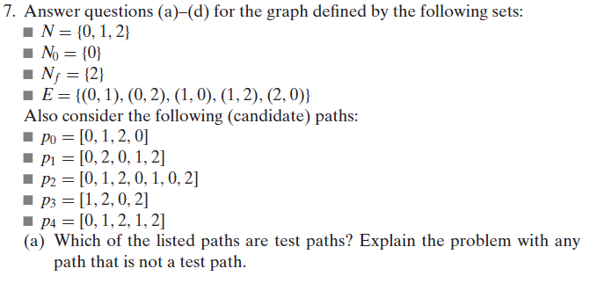

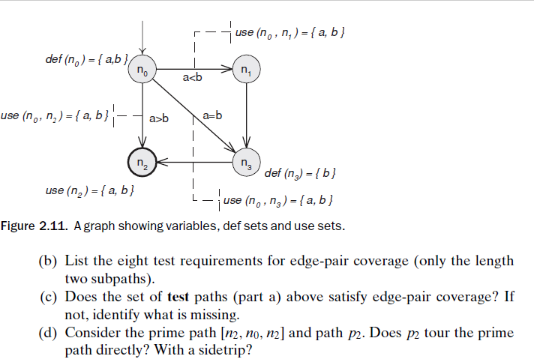

G = <N, N0, Nf, E>

Nodes (N): {0, 1, 2}

Node 0: Initial node (N0)

Node 2: Final node (Nf)

Edges (E): {(0, 1), (0, 2), (1, 0), (1, 2), (2, 0)}

1. The paths P1 and P2 are test paths because they start at the initial node (1), include existing edges and finish at the final node (2). However, P3 doesn’t isn’t a test path since the path starts at 1 instead of 0, the initial node. Even though P4 starts at the initial node and ends at the final node, it contains an edge that does not exist and so it is not a test path either.
2. TR = {[(0,2),(2,0)], [(1,2),(2,0)], [(2,0),(0,1)], [(0,1),(1,2)], [(0,1),(1,0)], [(1,0),(0,2)],

[(2,0),(0,2)], [(1,0),(0,1)]}

1. The test paths P1 = [0, 2, 0, 1, 2] and P2 = [0, 1, 2, 0, 1, 0, 2] don’t satisfy edge pair coverage. This is no tour for edge pairs [(2, 0), (0, 2)] and [(1, 0), (0, 1)].
2. P2 doesn’t tour the prime path [n2, n0, n2] directly. However, p2 tours this prime path with the sidetrip [n0, n1, n0].